**Topic Predict iPhone Price**

**Name Sandeep Jain**

**Mobiles phone**

**come in all sorts of prices, features, specifications and all. Price estimation and prediction is an important part of consumer strategy. Deciding on the correct price of a product is very important for the market success of a product.**

**Data**

|  |  |
| --- | --- |
| Version | Price |
| 1 | 13999 |
| 2 | 23999 |
| 3 | 26999 |
| 4 | 64789 |
| 5 | 62998 |
| 6 | 87900 |
| 7 | 79899 |
| 8 | 95599 |
| 9 | 95599 |
| 10 | 99699 |
| 11 | 115000 |
| 12 | 113900 |
| 13 | 120000 |
| 14 | 132999 |

**Code to Calculate Future iPhone Price**

**data=read.csv("C:/admin.csv")**

**data**

**b=data$version #version**

**c=data$price #price**

**d=cor(b,c)**

**d**

**plot(b,c)**

**model=lm(c~b)**

**model**

**summary(model)**

**x=14 #model number**

**price=-22468+11450*(x)**

**print(price)**

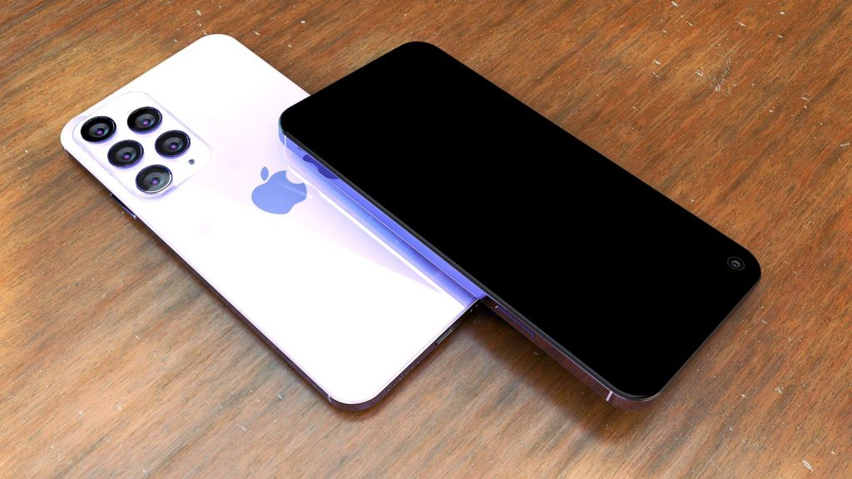

**Predict iPhone 14 Price.**

**Predict iPhone 15 Price.**

**Predict iPhone 30 Price.**





**Conclusion 🡪 We can Predict iPhone Price with help of this formula**



